# MODUL 12 FLIPGRID VIDEO PRESENTATION: MY FUTURE PLANS

|  |  |
| --- | --- |
|  | CAPAIAN PEMBELAJARAN |
| Siswa mampu melakukan presentasi singkat dalam Bahasa Inggris tentang rencana masa depan mereka menggunakan Bahasa Inggris yang baik dan benar melalui aplikasi Flipgrid. | |

|  |  |
| --- | --- |
|  | KEBUTUHAN ALAT/BAHAN/SOFTWARE |
| * Computer/Laptop * LCD Proyektor * Speaker audio * Copy materi (hard/soft copy) | |

|  |  |
| --- | --- |
|  | DASAR TEORI |

For this module, you are required do a simple presentation. Below are some of the things you can do to present your ideas better.

**1. Think About the Details in Advance**

Prepare beforehand, the location of the presentation, equipment, materials, timing, your appearance and outfit to help you avoid nervousness. Preparation is the key for a successful presentation.

**2. Do Your Homework**

Before presentation, prepare the following:

* Prepare the topic of the presentation: title and goal
* Think about who your audience is
* Decide on your main message (pesan utama)
* Outline the structure of the presentation: the opening, the main part and the summary
* Use simple language
* Make the presentation simple, you only have limited time
* Prepare a note to help your present your ideas

**3. Introduce Yourself and Set the Theme**

At the beginning of the presentation, introduce yourself, give your full name, student number, major and class. Then, you can state the topic of your presentation.

You can use the following useful phrases:

*“Hello, ladies and gentlemen, thank you for coming…”*

*“The topic of today’s meeting is…”*

*“Let’s get the ball rolling”*

*“Shall we get started?”*

**4. Provide an Outline or Agenda of Your Presentation**

Prepare an outline of the presentation. That’s why the opening part is very important. Make it cheerful, interesting and catchy. Memorize it well, , so you don’t forget it even if you are nervous.

You can use the following useful phrases in English:

*“I’d like to give you a brief outline of my presentation…”*

*“Here is the agenda for the meeting…”*

*“My presentation consists of the following parts…”*

*“The presentation is divided into four main sections…”*

*“I will talk about….”*

**5. Make a Clear Transition in Between the Parts of the Presentation**

Using transition words and phrases in English makes your presentation look smooth and easy to follow.

Useful phrases in English:

*“I’d like to move on to another part of the presentation…”*

*“Now I’d like to look at…”*

*“For instance…”*

*“In addition…”*

*“Moreover…”*

*“This leads me to the next point…”*

**6. Wow Your Audience**

Use adjectives and descriptive words as they will help to attract the audience’s attention and make your speech more vivid and memorable.

Useful phrases in English:

*“The product I present is extraordinary.”*

*“It’s a really cool device”*

*“This video is awesome”*

*“This is an outstanding example”*

**7. Summarize**

At the end of the presentation, briefly summarize the main points and ideas. End of the presentation by thanking all the listeners and inviting them to the Q&A.

Useful phrases in English:

*“Let’s summarize briefly what we’ve looked at…”*

*“In conclusion…”*

*“I’d like to recap…”*

*“I’d like to sum up the main points…”*

**8. Practice**

Try rehearsing your presentation using the above tips. Practice in front of a mirror or with your friends, parents or spouse. The more you practice, the better. While practicing, try not to use crutch words (examples: uhhhhh, ahhhh, so on, you know, like etc.)

Good luck with your presentation!

Cr: Alena Khabibullina from <https://www.ilac.com/tips-for-giving-a-great-presentation-in-english/>

|  |  |
| --- | --- |
|  | PRAKTIK |

Prepare a short presentation about your future plan, five year from now. You can use the outline below (do not copy and paste, make your own sentences).

|  |  |  |
| --- | --- | --- |
| No | Part | Content |
| 1. | Greeting and Self Introduction | Hello Gaes!  My name is…………  My Student Number is …………….  I am from class……  My major is….. |
| 2 | Introduction to topic | Today, I want to talk about my future plan. Five years from now, I will…. |
| 3 | Content Dreams and How (min 10 sentences) | * I will graduate from university. I am going to… * I will work in an IT company in Jakarta. * I will have a wonderful boyfriend/girlfriend. * I will have a lot of money… * Dst….. |
| 4 | Summary | In summary, I will live happily five years from now. I will graduate, work, have boy/girlfried and money..etc. |
| 5 | Closing | I think that’s all from me. I hope you enjoy my presentation. I’m sorry if I make any mistakes in my presentation. |
| 6 | Leave Taking | Thank you, see you soon.  Stay safe, happy and healthy….^^ |

|  |  |
| --- | --- |
|  | **LATIHAN DAN TUGAS** |

Please upload your video with the following guidelines:

1. Prepare your presentation before accessing the link.
2. Open link : <https://flipgrid.com/0ec7c54d>
3. Sign in using your **gmail.com** account only.
4. Or you can download and open **Flipgird** application or open **flipgrid.com** from your browser and input code: **0ec7c54d**

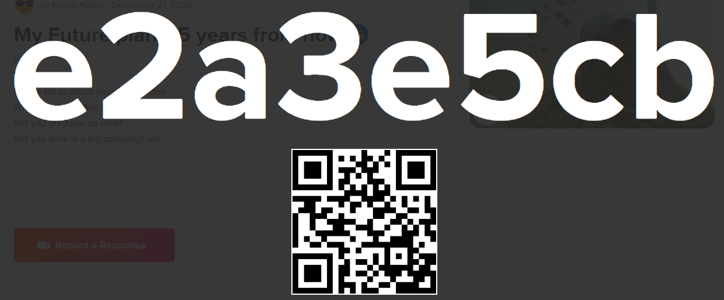

1. Read the direction carefully and play the video from your lecturer.
2. Click record a respond button (red button on web page, green button on application)

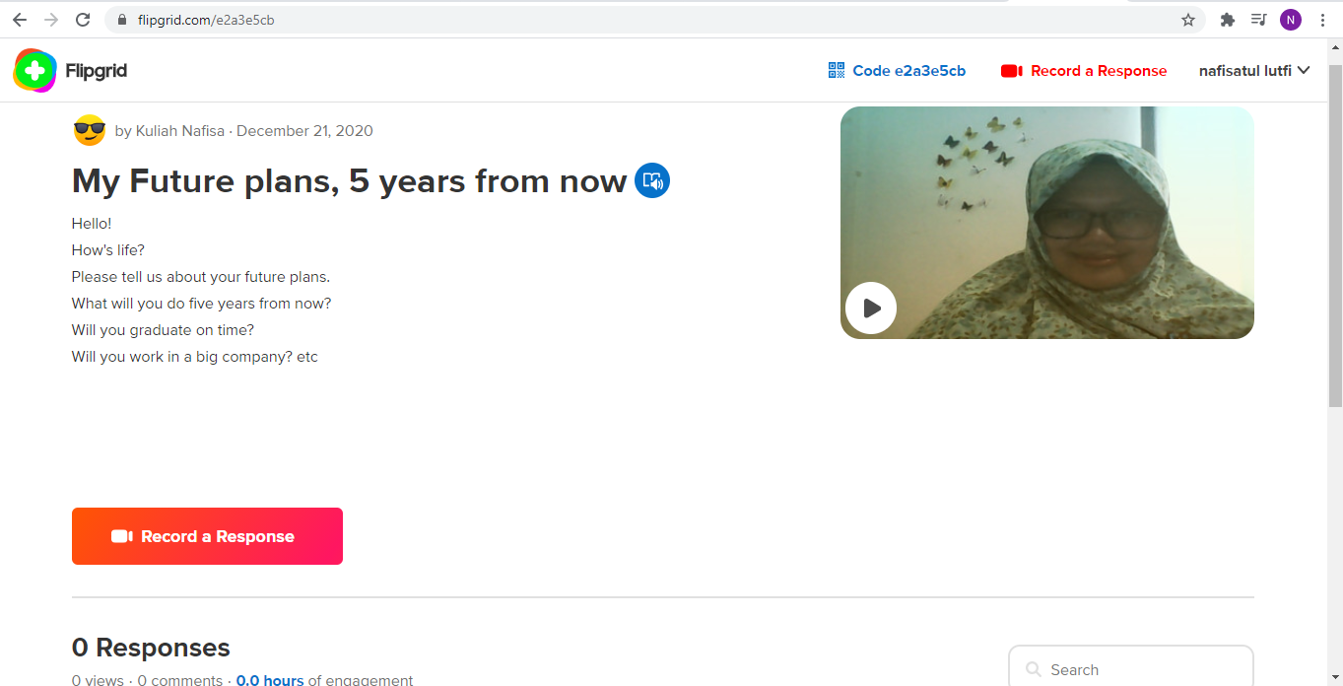

1. Record your video and edit it. You can add emoji, filters, note, etc.
2. Submit the Video with your NAME, NIM, MAJOR, CLASS

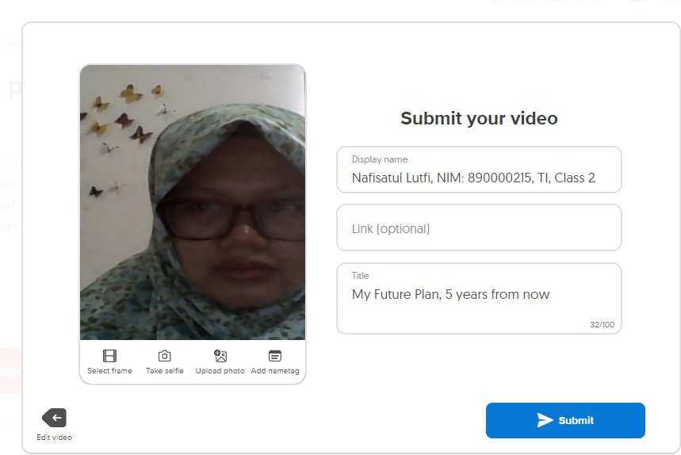

1. Click Submit and you’re done! ^o^/
2. You can watch your friends’ video as well.
3. NOTE: **MAXIMUM time is 5 MINUTES.**
4. DEADLINE**: 31 DECEMBER 2020**

|  |  |
| --- | --- |
|  | **REFERENSI** |

1. **Link video on my future plan presentation (sample):**

[**https://www.youtube.com/watch?v=J7FKP8JmKks**](https://www.youtube.com/watch?v=J7FKP8JmKks)

1. **Link video on how to be confident in a presentation:**

[**https://www.youtube.com/watch?v=tShavGuo0_E**](https://www.youtube.com/watch?v=tShavGuo0_E)

1. **Link video on how to use flipgrid for students (TUTORIAL FLIPGRID):**

**HP atau android :**

[**https://www.youtube.com/watch?v=A75cRD9vqqc**](https://www.youtube.com/watch?v=A75cRD9vqqc)

**Computer atau Laptop:**

[**https://www.youtube.com/watch?v=rLOEV_dL3rY**](https://www.youtube.com/watch?v=rLOEV_dL3rY)